Exercise 1: Implementing the Singleton Pattern
Solution:
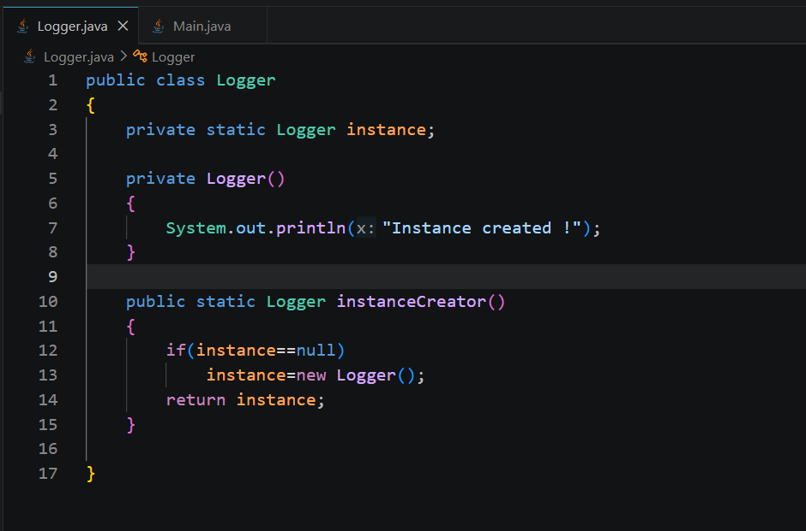
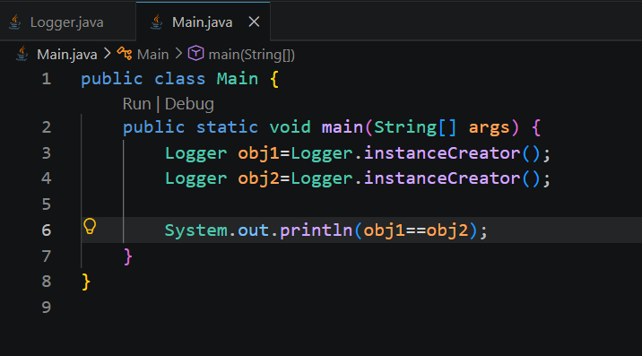

Output:
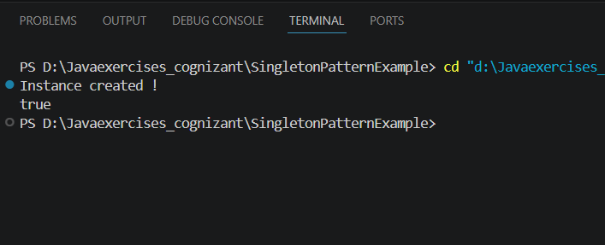

Conclusion:
The constructor is called only once, both s1 and s2 point to the same object.

